**Solution Vision**

**For**

**Nucleus**

**(Project Vulcan)**

|  |  |
| --- | --- |
| Project Name | Nucleus (Project Vulcan) |
| INVP # (if known) | 5905 |
| ITLT Sponsor | Simon Baker |
| IT Business Partner | Orla Daly |
| Domain Architect | Vikas Kadam |
| Solution Architect | Chris Sim (BCGDV-Boston Consulting Group - Digital Venture) |
| Infrastructure Architect | *TBD* |
| Security Architecture | Michael Isenberg |

**Contents:**

Business Vision 3

Business Scenarios 4

Stakeholders and their Concerns 5

Constraints 6

Business Architecture 7

Users and User Experience Expectations 8

Current State 9

Options 10

Phase 1 - Interim Architecture (Leverage CXP Portal) 11

Phase 2 - End-State Architecture (Salesforce Community) 15

Recommended Option and Rationale 18

# 

# Business Vision

Although commercial and industrial (C&I) customers are the minority of our customer base, they make up more than 50% of our total energy usage and 25% of revenue. Currently, the National Grid customer experience is mostly catered to residential customers. Commercial and industrial customers are currently underserved by our customer experience channels. The biggest pain point for our C&I customers is their billing and payment experience.

The nucleus is a platform that meets specific C&I needs. Features include:

* Custom account grouping
* Digital bill guidance
* Payment allocation
* Powerful usage analytics
* 1-click customer assistance
* Screen mirroring smart support

# 

# Business Scenarios

**Three Major Frictions Addressed:**

**The manual process to get a consolidated view of bills**

* Requires downloading each bill individually, in some cases 1,000+
* One bill per account, with each, added manually

**Bills are confusing**

* Bill layout difficult to digest
* Rate structures make little sense

**Lack of confidence in the bill’s accuracy**

* Billing errors
* Communicating exceptions is tedious and erratic

# 

# Stakeholders and their Concerns

# Constraints

# 

# Business Architecture

MVP Business Architecture

8.4 Interaction Management

8.5 Customer Work and Information Management

8.7 Customer Energy and Non-Energy Billing

8.8 Customer Credit and Revenue Collections Management

8.9 Customer Reporting and Performance Management

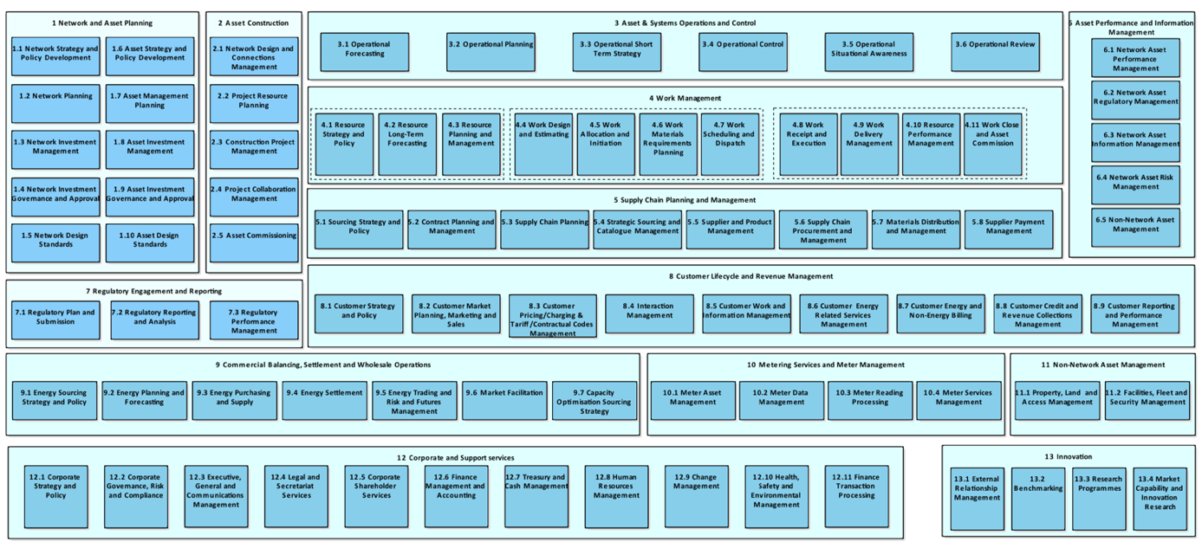

# Users and User Experience Expectations

**In-Scope User Personas**

|  |  |  |
| --- | --- | --- |
| Persona | Interacting Internal/External  to Corp Network | User Impact or User Expectations |
| Accounting Rep | External | Easily understand charges, track and process payments |
| Facilities Manager | External | Monitor and analyze usage trends. Generate reports for internal use |
| Transaction Support | Internal | Have a more comprehensive view of the customer accounts and be able to discuss products and services |
| Account Manager | Internal | Will be able to manage more accounts, strategically offer more EE programs and gain a deeper understanding of the customer |

An example of the benefits of the new user experience:

# 

# Current State



MyAccount

GridForce

Consolidated Bill (excel)

EPO

# 

# Options

The scope of the options analysis in this section pertains to the solution delivered at the end of the MVP phase of the project.

Analyzing the tiers in the Nucleus solution, we have identified that the scope of the interim/end-state architecture analysis relates to a small component of the business/domain tier. Regardless of the interim/end-state architecture option, a custom UI will need to be built and integration capabilities will also need to be built (to connect to CRIS/CSS for payment/billing functionality).

CRIS and CSS will eventually be replaced by the CIS (SAP implementation) and will contain all billing/payment/account data. A future SalesForce CRM implementation will house customer contact data (as relevant to Nucleus) only.

Mulesoft will be leveraged in all solutions, for example, routing logic to determine whether an account/billing/payment related request should go to CRIS/CSS (future CIS) will need to be built. Common services (to be reused by other projects), such as an API to aggregate multiple accounts for a single customer, will also be deployed to Mulesoft.

Therefore the current known scope for interim/end-state architecture relates to building the business logic for customer contact information in a new SalesForce communities instance (end-state architecture), or either leveraging existing profile APIs (already built) or expanding this capability as custom development (interim architecture).

## 

## Phase 1 - Interim Architecture (Leverage CXP Portal)

In this option, we will leverage existing capabilities that are being developed by CXP (Customer Experience Product) project. A comprehensive CXP program to fundamentally change how National Grid interacts, serves and communicates with customers. Its main focus areas are Web Self Service Platform and Identity Access Management Service, Preference Management, Personalization, Operational Data Store (ODS), Interactive Voice Response (IVR) and Automated Customer Service. The following architecture closely aligns with the CXP program and its architectural strategies and roadmap. We will develop the necessary UI/UX required to support Nucleus use cases, leverage and create/update MuleSoft APIs to access necessary data required from CSS, CRIS and new Azure-hosted database (for billing preferences).

**High-Level Solution Architecture (Interim Option)**

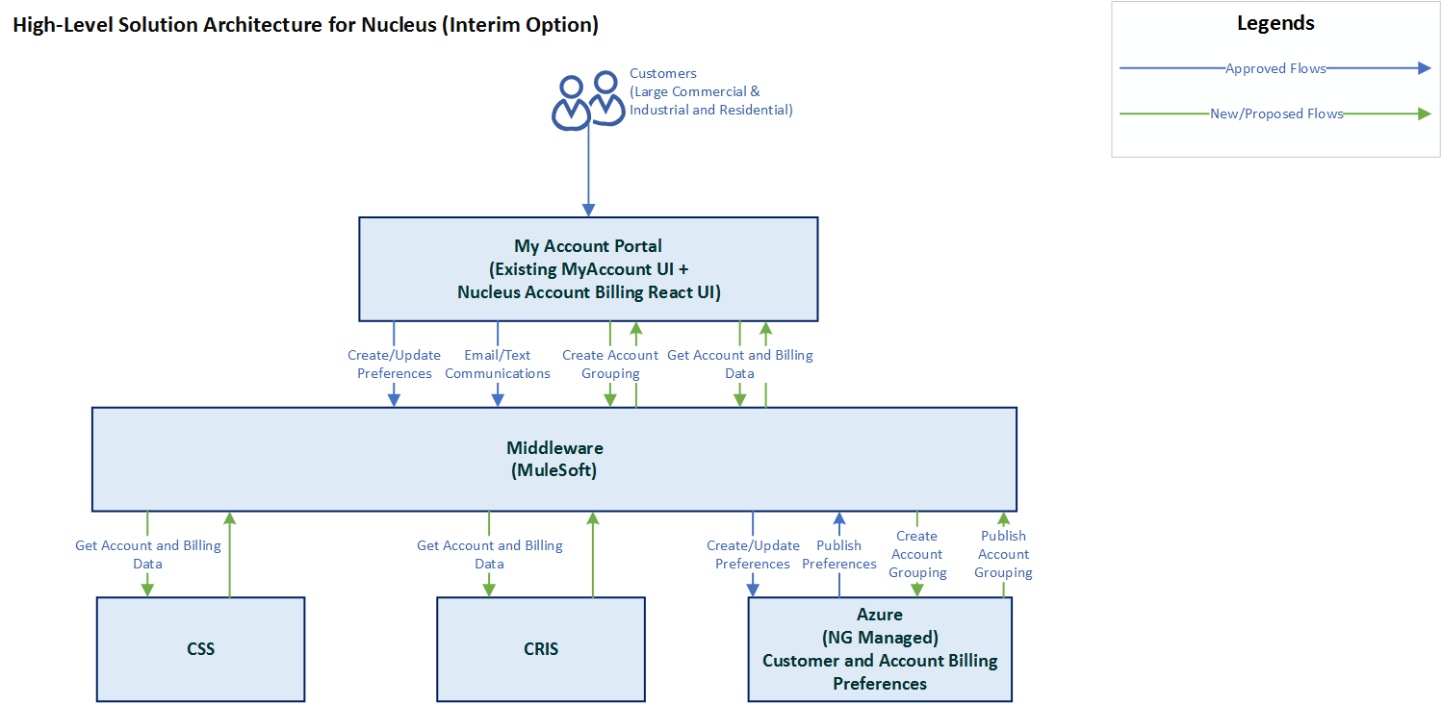

**Technology Disposition Implications**

|  |  |
| --- | --- |
| List All Proposed *New* Technology | Capabilities |
| React | It is an open-source JavaScript library created by Facebook for better UI development and efficient DOM manipulation. |
| Azure SQL database | Fully managed scalable Azure database |

**Integration Implications**

Expected Integration Scenarios

|  |  |
| --- | --- |
| Integration Category | Expected Use |
| API Integration (REST-based) | Yes |
| SOAP Integration | No |
| Queue Integration | No |
| ETL Integration | No |
| FTP Integration | No |

**Data Implications**

* Role-based access
* Data will be encrypted in transit and at rest

**Security Implications**

* Penetration Testing to verify the security of the solution
* Currently, no Enterprise-wide Authentication provisioning/de-provisioning being done independently.
* Need to know access – user roles need to be examined for broader deployment
* Least privilege access – user roles need to be examined for broader deployment
* Separation of duties – user roles need to be examined for broader deployment
* Logging capacity revaluated
* Ensure Auditing is enabled
* Secure coding best practices published and communicated
* Enable and Leverage SonarQube (SAST)
* Desire Dynamic Code analysis (DAST)
* Incident Response Plan
* Re-occurring Vulnerability Scans
* Malware Defence
* Endpoint security
* DLP detection enabled and monitored
* Account Management - Joiner, Leaver, and Mover
* Security edge service management and support to be re-evaluated

**Other Non-Functional Implications**

* Disaster Recovery – leverage existing DR plan of CXP - My Account Portal
* High Availability – Solution/Component will be hosted on CXP infrastructure which highly available and scalable architecture
* Backup – NG standard backup policies will be followed to backup the mounted storage volumes (Follow CXP practices)

**Infrastructure Implications**

* Horizontal Scaling – More Virtual Machines can be added if needed (on-demand scalable)
* Vertical Scaling- Upgrade resources (CPU cores/memory/storage size), if required

**Commercial Implications**

* No commercial implication as this solution will leverage CXP - My Account infrastructure/Licenses.

**Pros/Cons**

|  |  |
| --- | --- |
| Pros | Cons |
| Azure is a National Grid approved platform | Building for MVP scope only |
| Ability to deploy separate instance with no dependency | Cloud DevOps required |
| Cost-effective |  |
| Ability to access data and apply analytics in real-time |  |
| Aligns with proven/approved Customer Experience Project architecture |  |
| Reuse existing Mulesoft connectors and services (profiles, payment accounts, etc.) |  |
| Reuse existing SSO and other UI components |  |
| Fast time to deliver value back to the business |  |
| Aligned with other CXP projects to move to SalesForce when available. |  |
| Payment/Account functionality will continue to reside in either CRIS/CSS or the new CIS (portal interfaces decoupled from these systems) |  |

## 

## Phase 2 - End-State Architecture (Salesforce Community)

**High-Level Solution Architecture (End-State Architecture)**

Within National Grid - there is general, strategic direction to leverage SalesForce products, where appropriate. The related products to the Nucleus are SalesForce CRM and SalesForce Communities. Given the scope of interim vs end-state architecture for Nucleus pertains to customer contact data, the decision to end-state architecture (leverage SalesForce) for the solution is dependent on all relevant (non-billing/payment) customer data being migrated over to SalesForce CRM. Additionally, the Nucleus project would also require the rebuilding of existing SSO and other common, existing portal functionality into SalesForce Communities before Nucleus specific functionality can be built.

Further - an existing database and API already exists to provide access to customer profile data. This is the core functionality that Nucleus would leverage, in relation to SalesForce Communities, and would need to be migrated over to SalesForce in order for it to be usable and available.

With a SalesForce backend, however, SalesForce SDKs can be leveraged within the React UI. These SDKs abstract away calls to the SalesForce backend, but the gain here, based on likely functionality provided by a SalesForce CRM/Communities backend is negligible.

SalesForce does provide billing and payment capabilities. In the case of billing, it is tightly coupled with Salesforce CPQ (Configure, Price, and Quote) products. It also focuses on recurring customer relationships providing one-time, subscription or usage-based pricing models. The focus mainly on subscription business and may not be suitable for National Grid’s customers.

SalesForce’s appexchange provides payment processing capabilities via vendors like Chargent and others. We’re not trying to solve and/or change our payment processes. We would be leveraging our existing payment processing capabilities.

In this case, we would only be using the Salesforce Community portal with additional necessary custom UI.

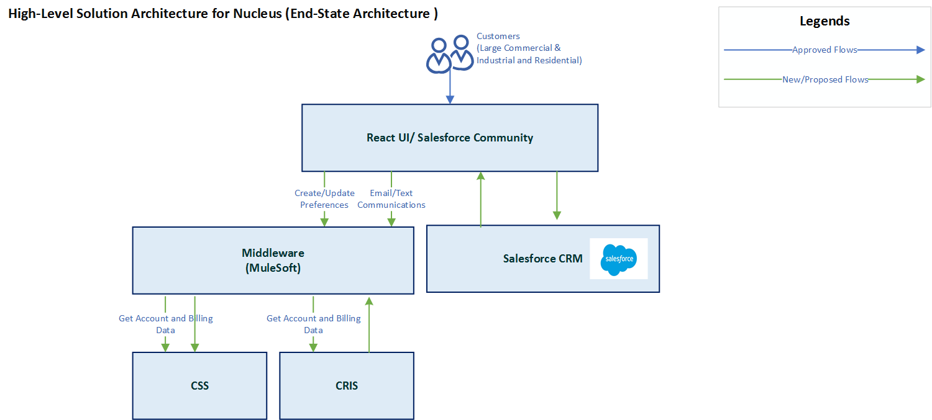

**Technology Disposition Implications**

|  |  |
| --- | --- |
| List All Proposed *New* Technology | Capabilities |
| Salesforce Community Cloud | A community cloud is a social platform from Salesforce.com that is designed to connect and facilitate communication between an organization’s employees, partners, and customers. |
| React | It is an open-source JavaScript library created by Facebook for better UI development and efficient DOM manipulation. |

**Integration Implications**

Expected Integration Scenarios

|  |  |
| --- | --- |
| Integration Category | Expected Use |
| API Integration | Yes |
| SOAP Integration | No |
| Queue Integration | No |
| ETL Integration | No |
| FTP Integration | No |

**Data Implications**

* Role-based access
* Data will be encrypted in transit and at rest

**Security Implications**

* Penetration Testing to verify the security of the solution
* Currently, no Enterprise-wide Authentication provisioning/de-provisioning being done independently.
* Need to know access – user roles need to be examined for broader deployment
* Least privilege access – user roles need to be examined for broader deployment
* Separation of duties – user roles need to be examined for broader deployment
* Logging capacity revaluated
* Ensure Auditing is enabled
* Secure coding best practices published and communicated
* Enable and Leverage SonarQube (SAST)
* Desire Dynamic Code analysis (DAST)
* Incident Response Plan
* Re-occurring Vulnerability Scans
* Malware Defence
* Endpoint security
* DLP detection enabled and monitored
* Account Management - Joiner, Leaver, and Mover
* Security edge service management and support to be re-evaluated

**Other Non-Functional Implications**

* Disaster Recovery – SalesForce Communities is a SaaS solution. No dedicated DR infrastructure required.
* High Availability – SalesForce Communities is a SaaS solution.
* Backup – SalesForce Communities is a SaaS solution.

**Infrastructure Implications**

* SaaS SalesForce Communities - no infrastructure implication.

**Commercial Implications**

* No commercial implication as this solution will leverage CXP - My Account infrastructure/Licenses.

**Pros/Cons**

|  |  |
| --- | --- |
| Pros | Cons |
| National Grid approved platform | Lengthy customer data migration needed as US Customer data, not in CRM currently |
| Strong product synergies when combined with CRM | No native billing functionality |
| Managed Solution | Platform dependencies and limitations impact development speed |
|  | Specialized resources required |
|  | Inability to synchronize data updates between salesforce, CSS and CRIS |
|  | Use of 3rd party software libraries requires workarounds |

# 

# Recommended Option and Rationale

The recommendation is to implement Phase 1 – interim architecture and leverage existing capabilities. As this option gives more flexibility and on-demand scalability, also it is in alignment with the existing program (Customer Experience Product) and National Grid Enterprise Architecture guiding principles.

As and when the CXP program migrates to Salesforce Community, the Nucleus will also be migrated seamlessly to the Salesforce Community platform.